**Phase 1 Criterion A: Comprehending Spoken and Visual Text**

Name: ____________________________________________________

Date: __________________________________

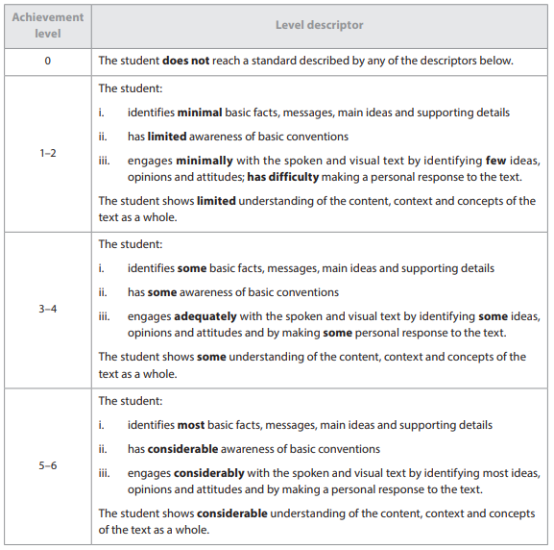

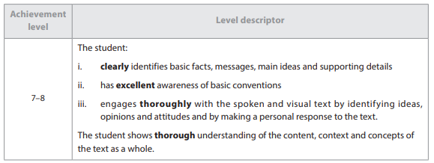

**Commentary**: _________________________________________________________

____________________________________________________________________________________________________________________________________________________________________________________________________________________________________________________________________________________________________________________________________________________________________________________________________________________________________

**IB Grade**: _____________ **Conversion**: ________________

**Phase 1 Criterion A: Comprehending Spoken and Visual Text**

Name: ____________________________________________________

Date: __________________________________





**Commentary**: _________________________________________________________

____________________________________________________________________________________________________________________________________________________________________________________________________________________________________________________________________________________________________________________________________________________________________________________________________________________________________

**IB Grade**: _____________ **Conversion**: ________________

**Phase 1 Criterion B: Comprehending Written and Visual Text**

Name: ____________________________________________________

Date: __________________________________

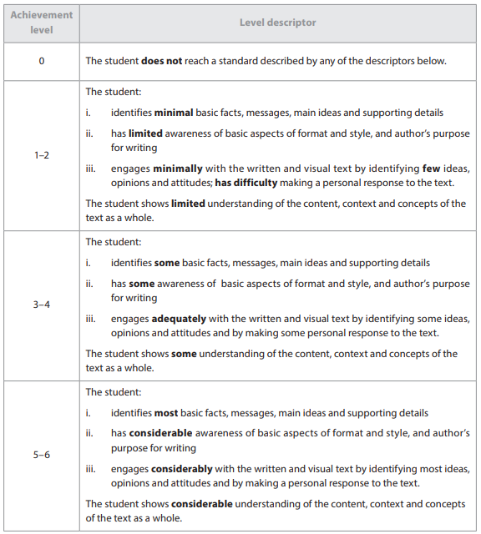

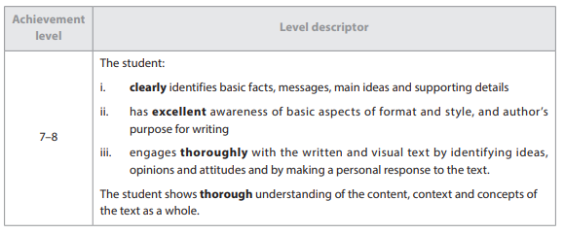

**Commentary**: _________________________________________________________

____________________________________________________________________________________________________________________________________________________________________________________________________________________________________________________________________________________________________________________________________________________________________________________________________________________________________

**IB Grade**: _____________ **Conversion**: ________________

**Phase 1 Criterion B: Comprehending Written and Visual Text**

Name: ____________________________________________________

Date: __________________________________





**Commentary**: _________________________________________________________

____________________________________________________________________________________________________________________________________________________________________________________________________________________________________________________________________________________________________________________________________________________________________________________________________________________________________

**IB Grade**: _____________ **Conversion**: ________________

**Phase 1 Criterion C: Communicating in Response to Spoken, Written and Visual Text**

Name: ____________________________________________________

Date: __________________________________

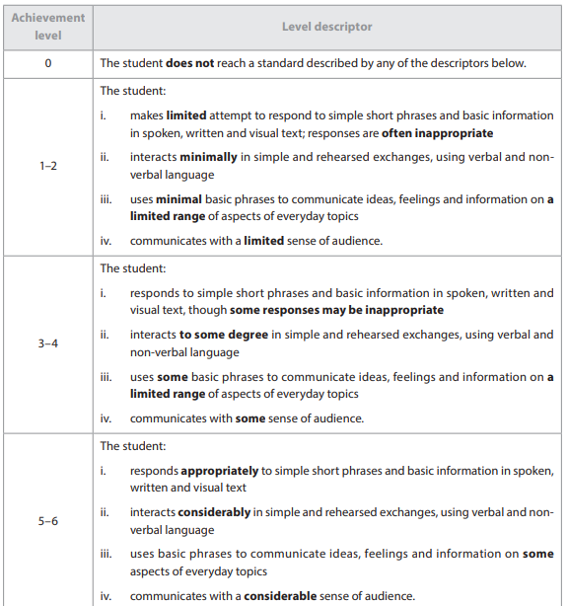

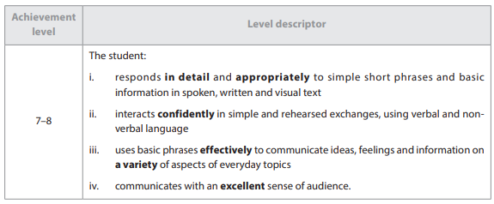

**Commentary**: _________________________________________________________

____________________________________________________________________________________________________________________________________________________________________________________________________________________________________________________________________________________________________________________________________________________________________________________________________________________________________

**IB Grade**: _____________ **Conversion**: ________________

**Phase 1 Criterion C: Communicating in Response to Spoken, Written and Visual Text**

Name: ____________________________________________________

Date: __________________________________





**Commentary**: _________________________________________________________

____________________________________________________________________________________________________________________________________________________________________________________________________________________________________________________________________________________________________________________________________________________________________________________________________________________________________

**IB Grade**: _____________ **Conversion**: ________________

**Phase 1 Criterion D: Using Language in Spoken and Written Form**

Name: ____________________________________________________

Date: __________________________________

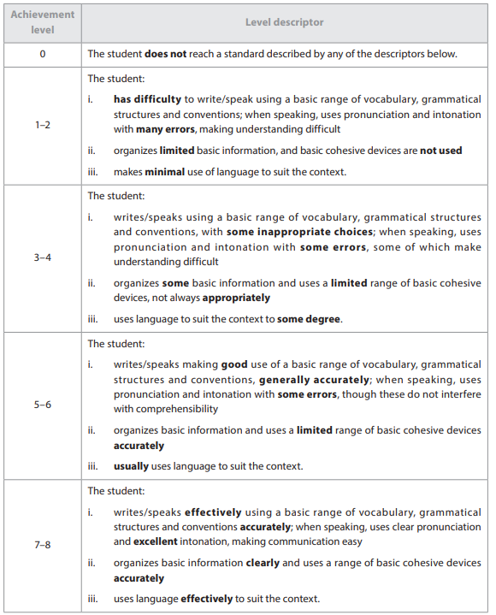

**Commentary**: _________________________________________________________

____________________________________________________________________________________________________________________________________________________________________________________________________________________________________________________________________________________________________________________________________________________________________________________________________________________________________

**IB Grade**: _____________ **Conversion**: ________________

**Phase 1 Criterion D: Using Language in Spoken and Written Form**

Name: ____________________________________________________

Date: __________________________________



**Commentary**: _________________________________________________________

____________________________________________________________________________________________________________________________________________________________________________________________________________________________________________________________________________________________________________________________________________________________________________________________________________________________________

**IB Grade**: _____________ **Conversion**: ________________